Deploying aks cluster using biceps,az client and terraform:

* Github: <https://github.com/Abhiramikannan/docker-spring-boot.git>
* Import this on aex.dev.azure.com
* Added: aks-cluster.bicep(code for creating aks cluster using biceps)

**Using azure cli:**

* Opened:

azure portal:

1. **Created a vm:**

* az group create --name abhi-rg-12 --location eastus
* az vm create --resource-group abhi-rg-12 --name abhi-vm --image "Ubuntu2204" --size Standard_B1s --vnet-name abhi-vnet-2 --subnet abhi-subnet-2 --admin-username abhi --admin-password Abhirami@12345
* connected to the vm:
  + ssh abhi@20.169.216.239

Opened:

Aex.azure.dev.com

* project settings -> agent pool -> add pool

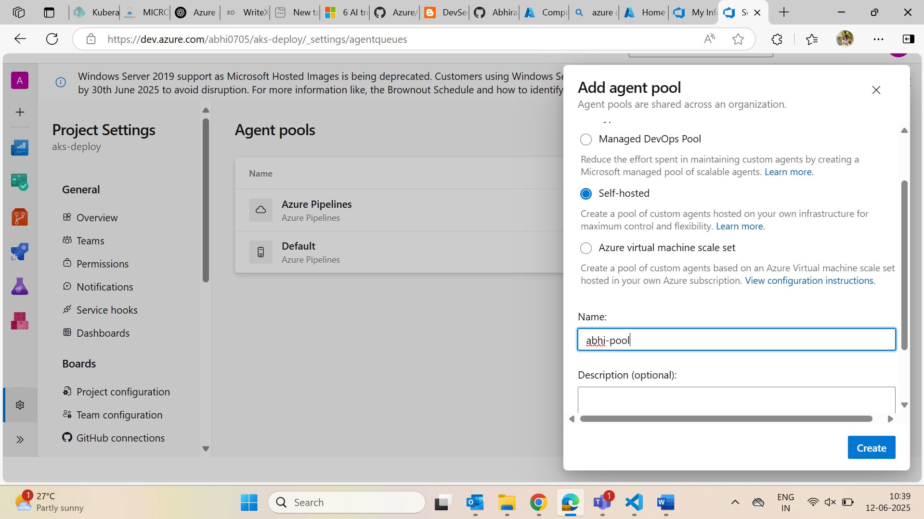

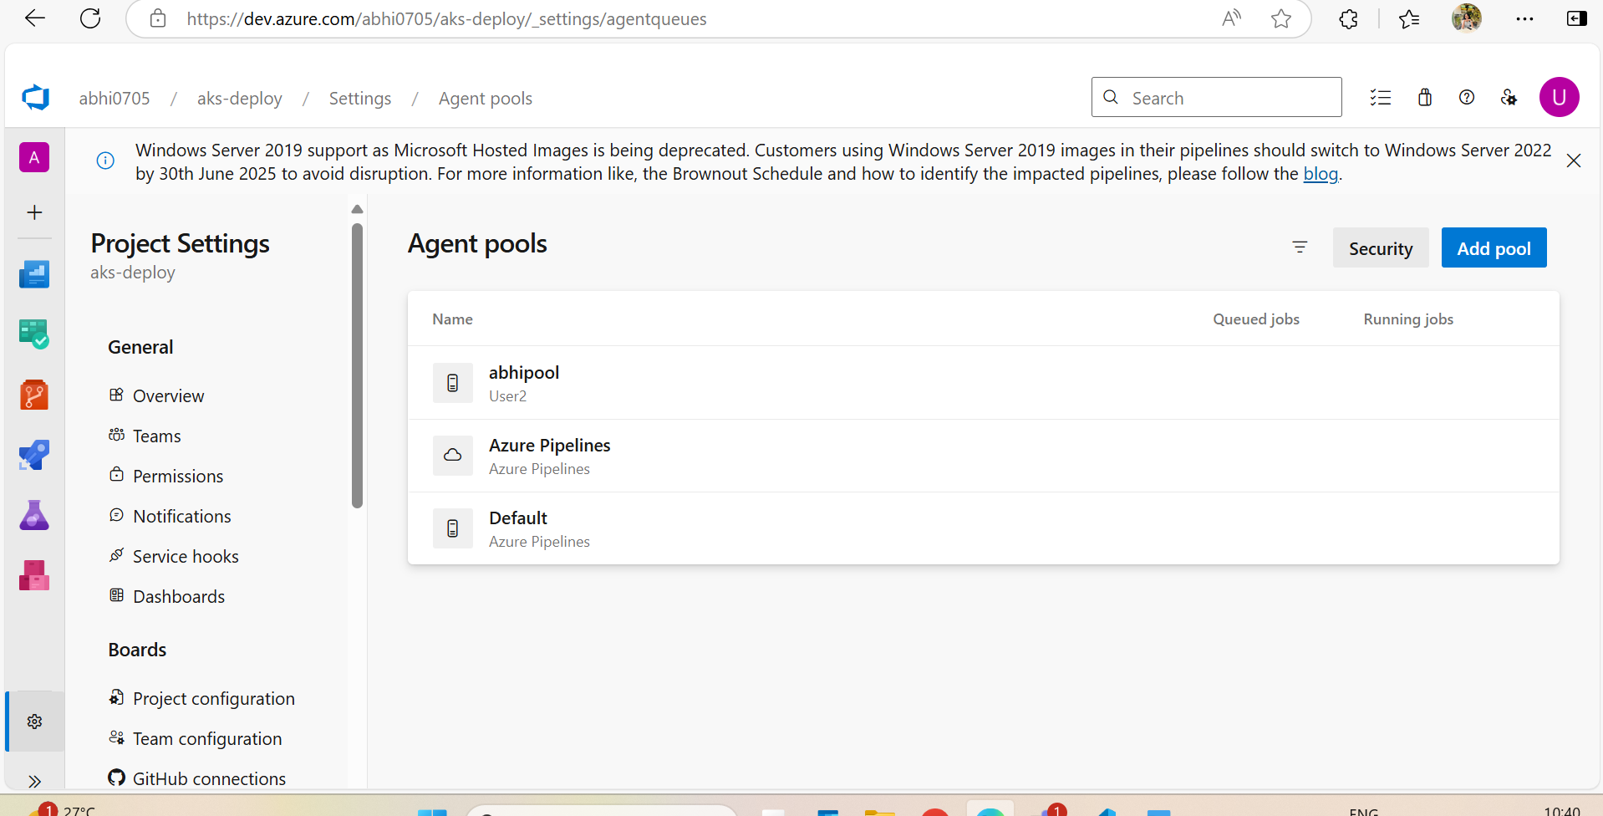

* adding an agent
* linux

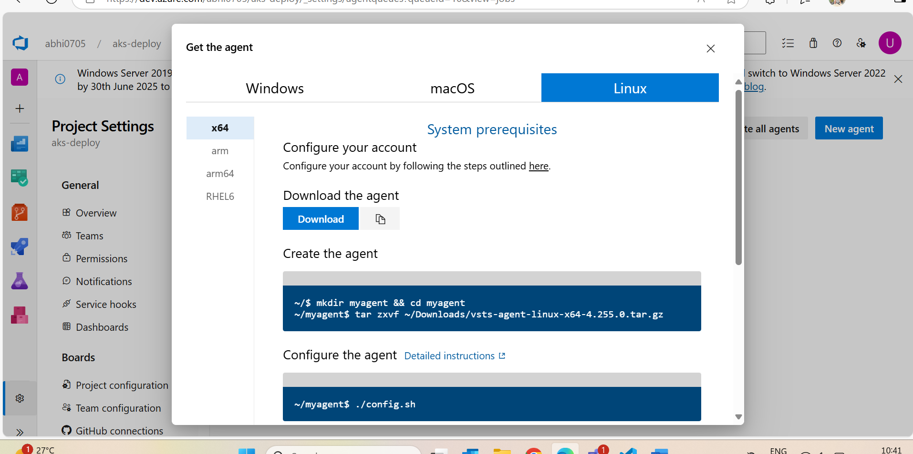

* steps inside vm:

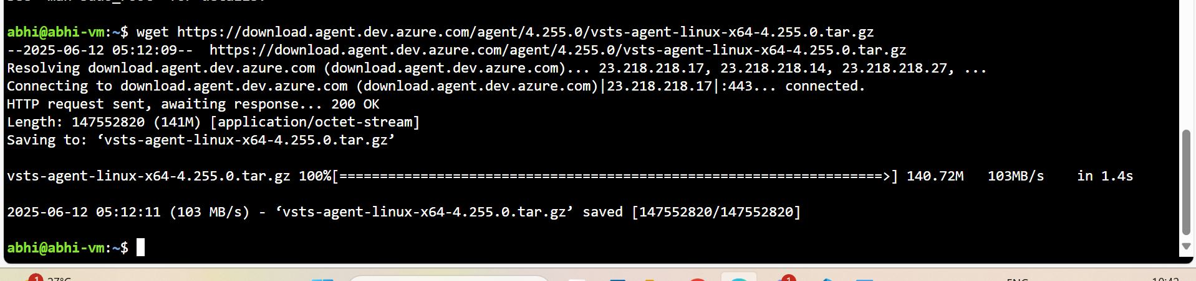

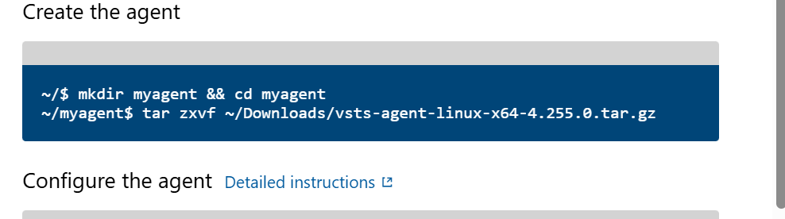

I have changed the location as tar zxvf ../vsts-agent-linux…………

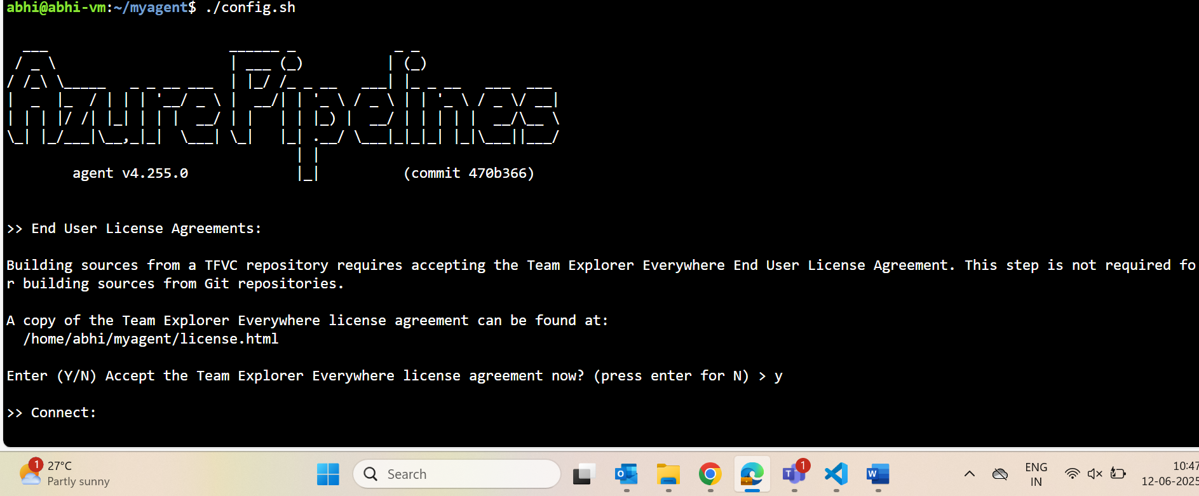

* generated pat from aex.dev.azure.com and gave here

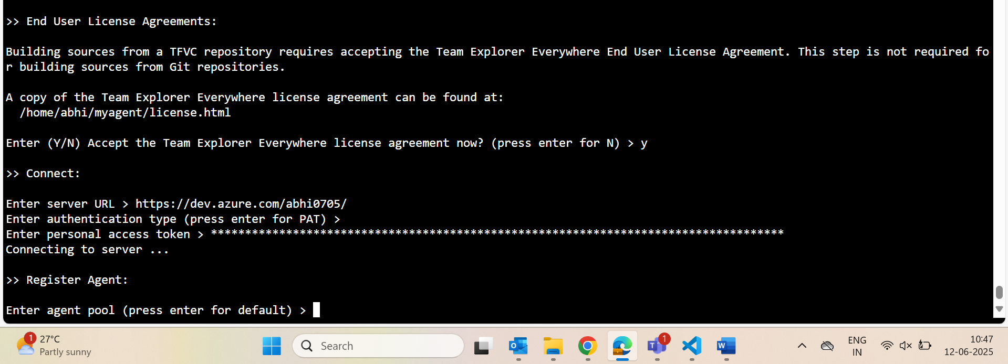

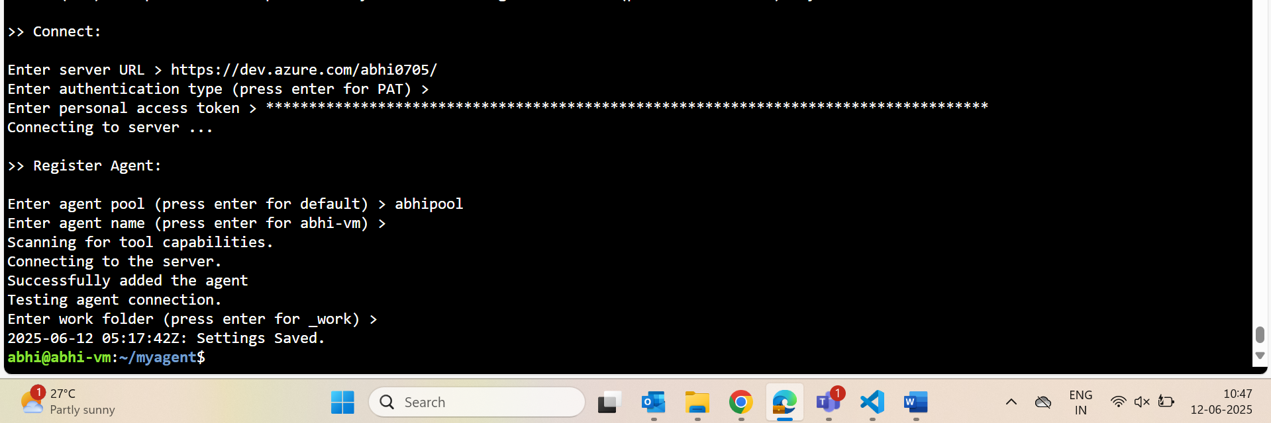

Commads for creating got from: [DevSecOps and Cloud Computing Coaching: Search results for azure pipeline to deploy to aks](https://www.coachdevops.com/search?q=azure+pipeline+to+deploy+to+aks)

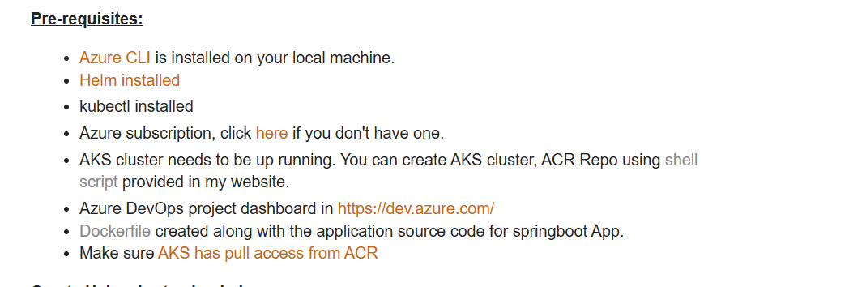

Click shell

* **create aks using az client**
  + az aks create --resource-group abhi-rg-12 --name abhiakscluster --node-count 1 --generate-ssh-keys --node-vm-size standard_B2s

**create container registry using az client**

* + az acr create --resource-group abhi-rg-12 --name abhiregistry --sku Standard --location eastus

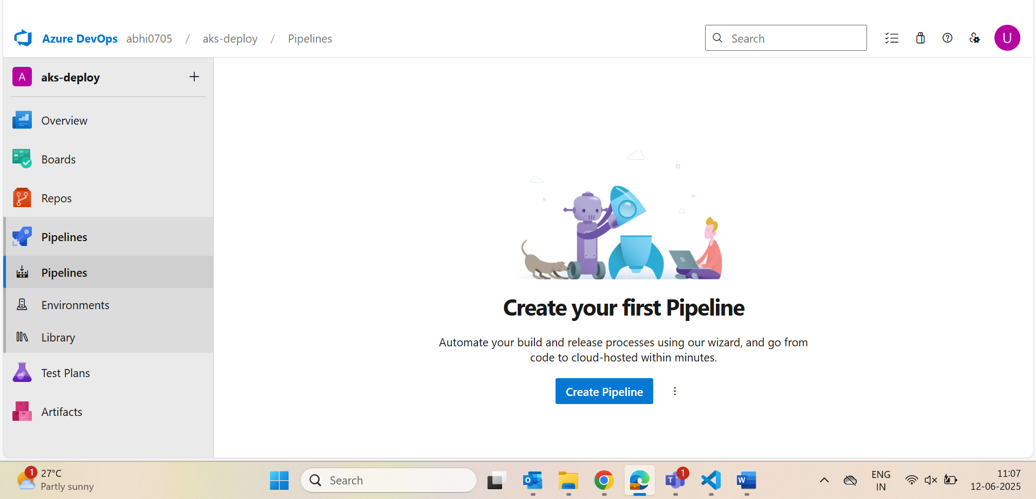

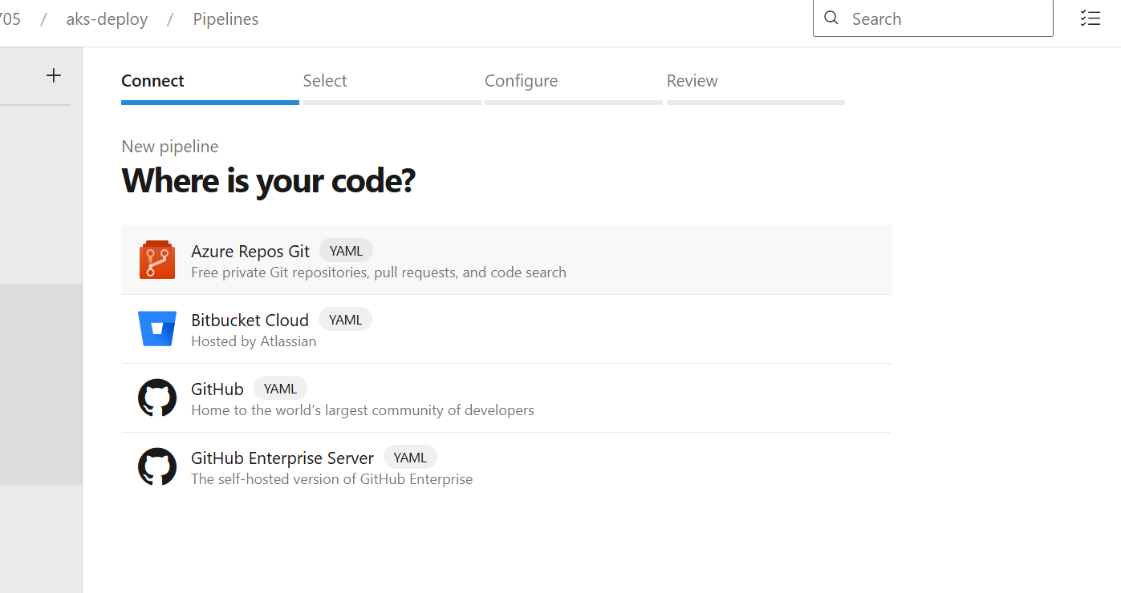

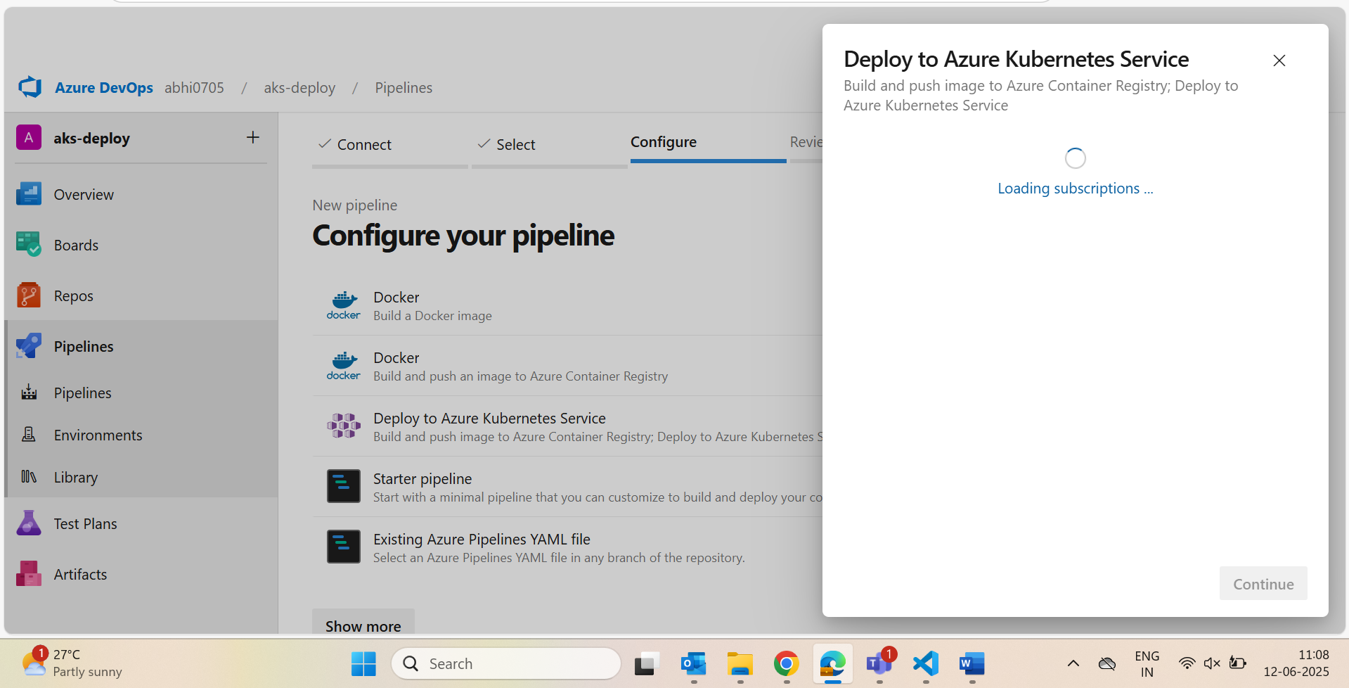

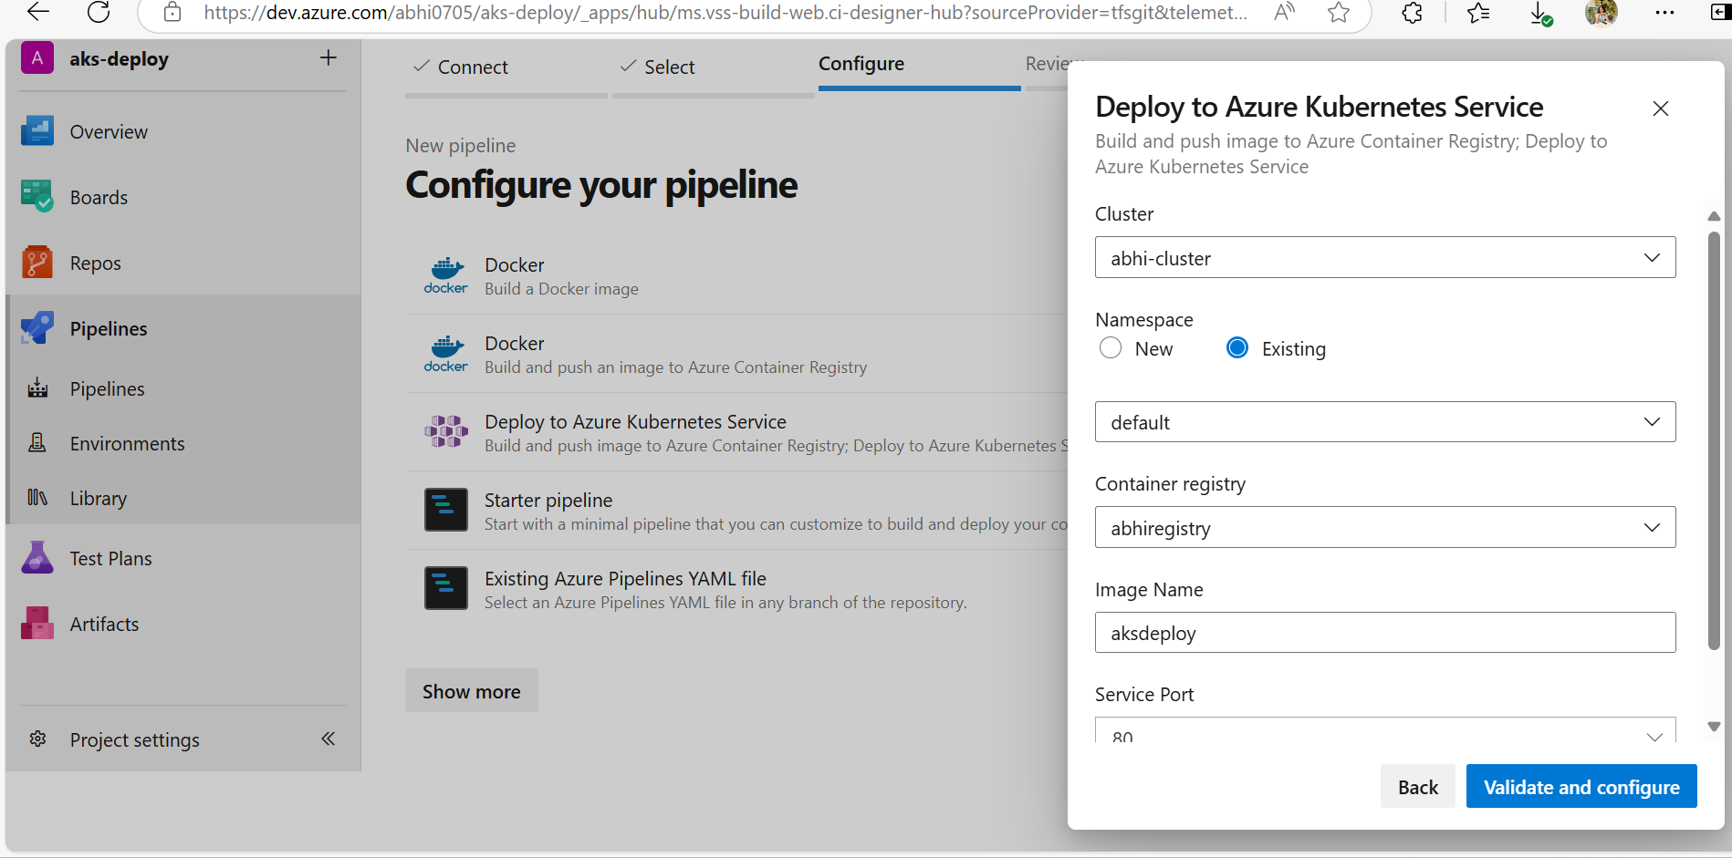

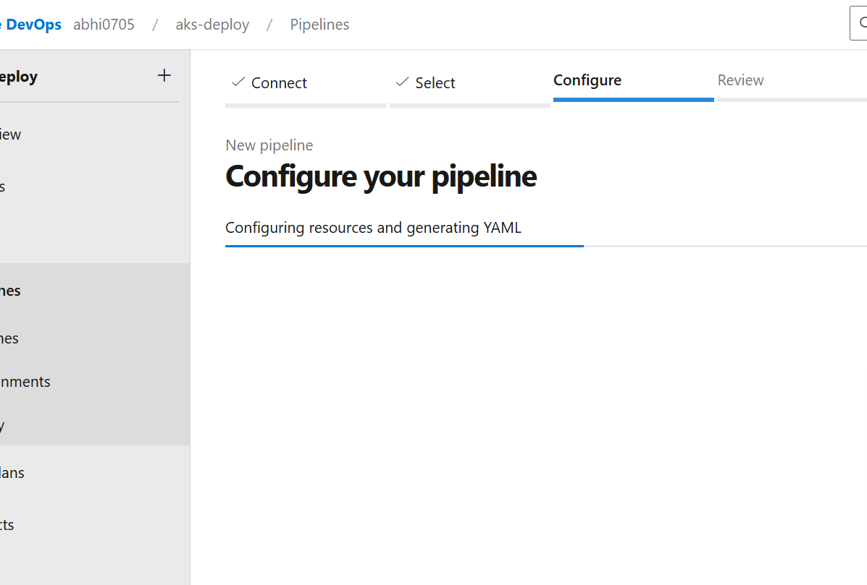

* + Gave pipeline automatically and we need to insall maven and docker
  + 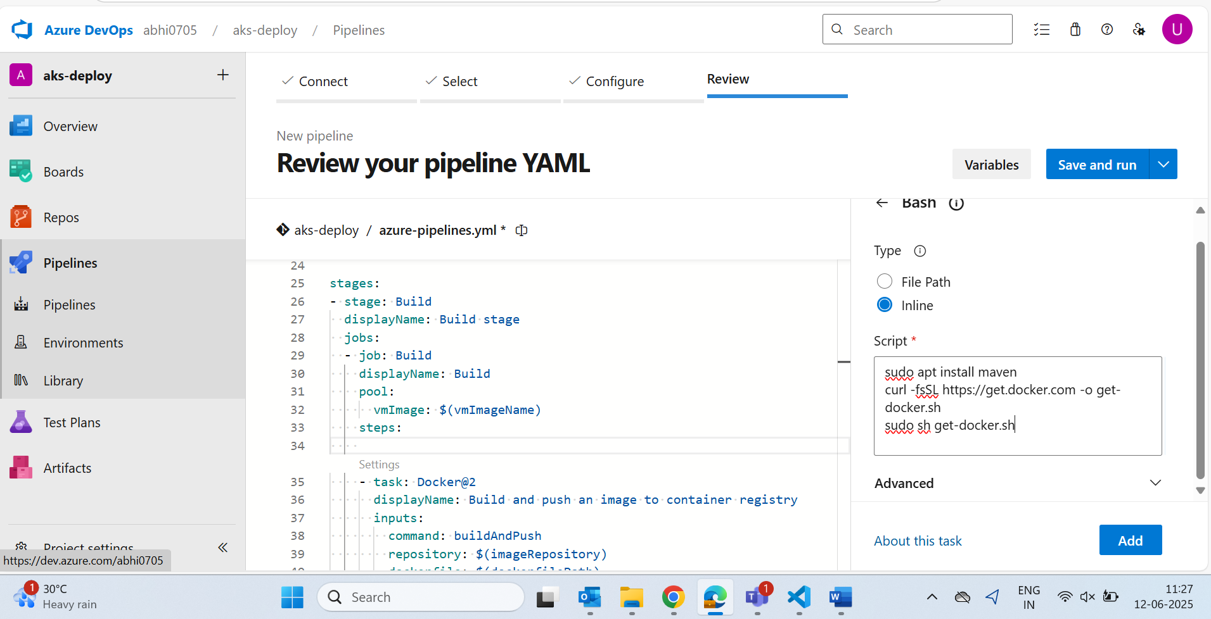
  + For mvn clean install a package manager is there ..search maven and will give that
  + Either u can give here as shell and execute commands
  + Otherwise in the workspace like jenkins
  + 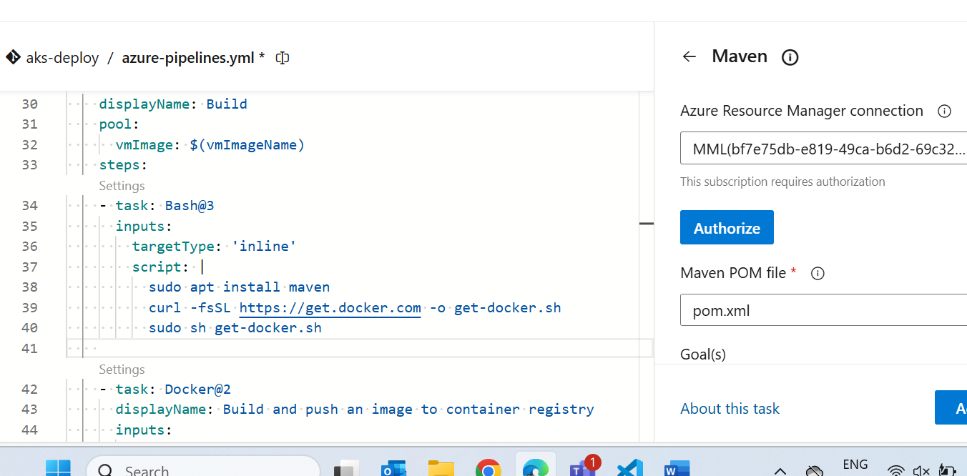

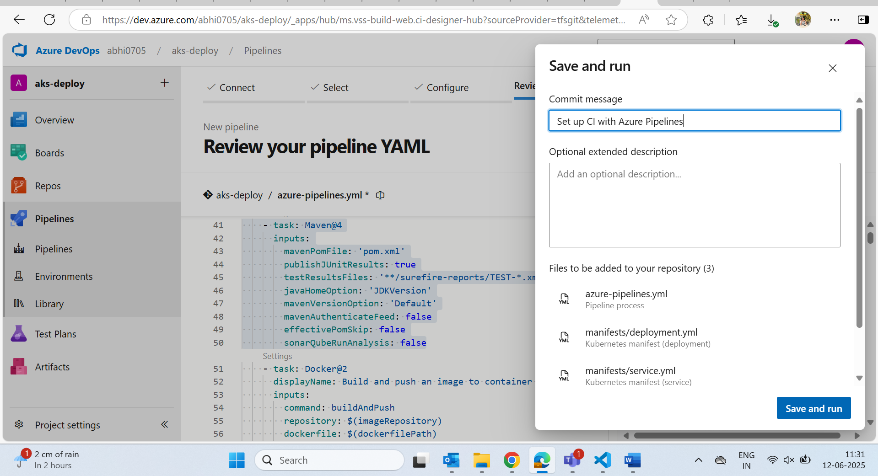

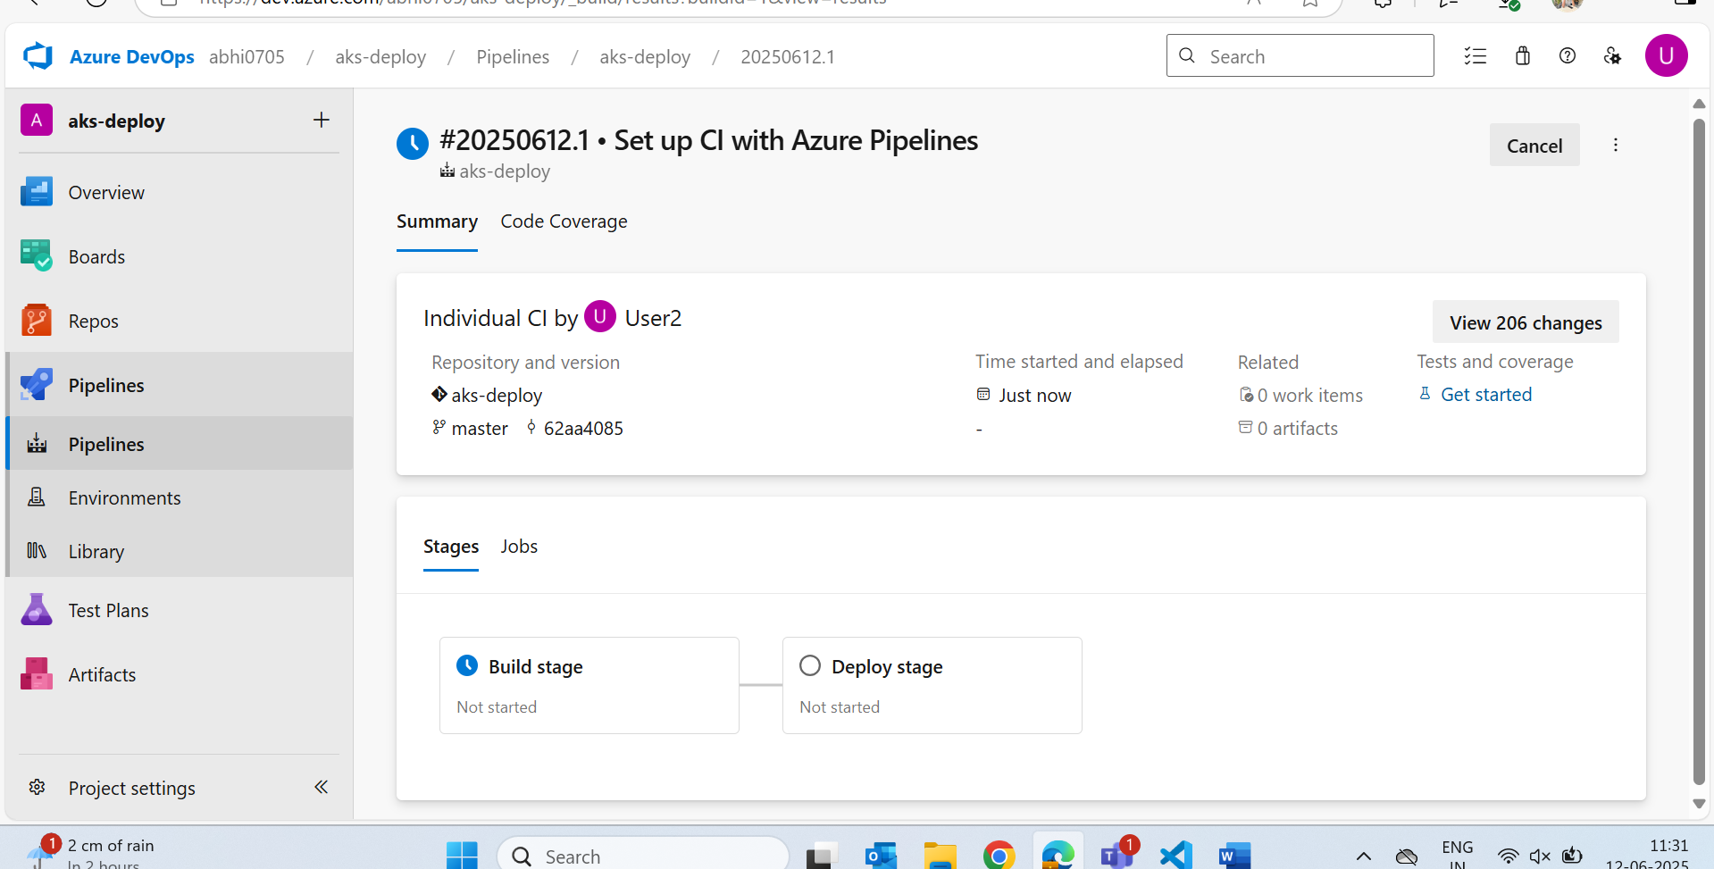

Edit:

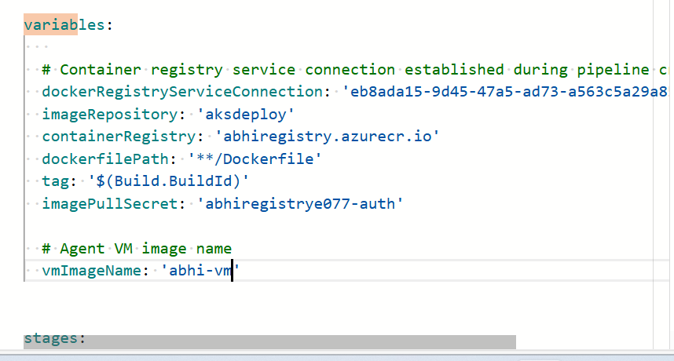

Give pool name that u have given in pool wherever it comes otherwise it takes default and gives error

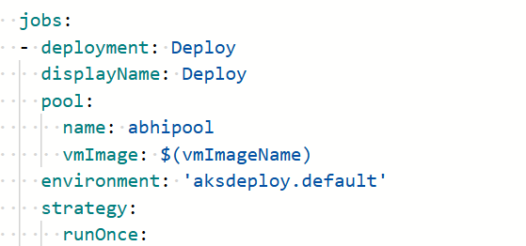

* Before build

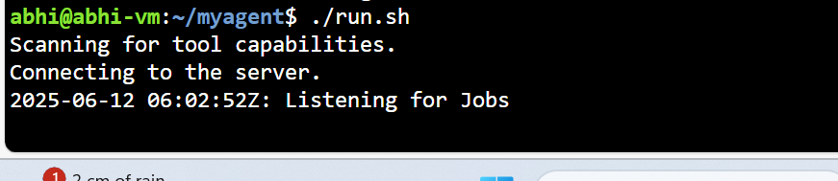

Then only agent listens

* Run

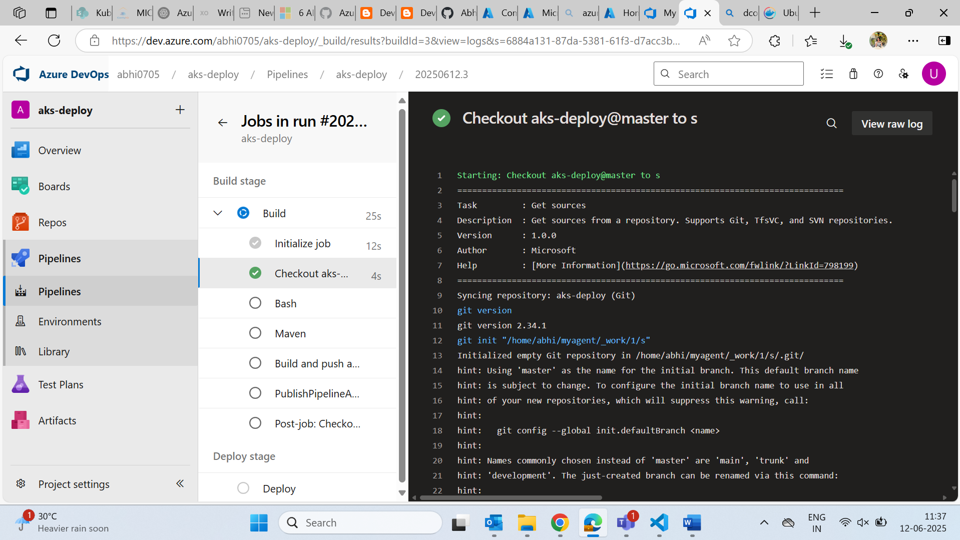

* Give vm size as standard_B2s(can resize)
* We will get an error:

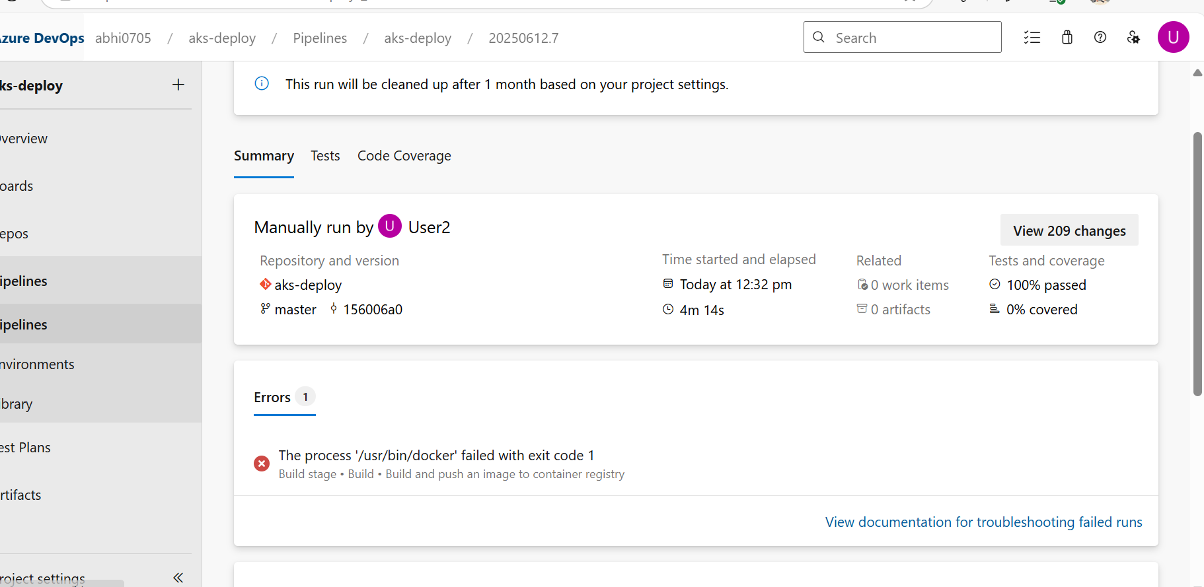

* Inside vm:



* This abhi user does not have any permission for docker
* So sudo usermod -aG docker abhi

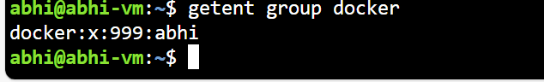

* Exit and renter to vm and check
  + docker ps

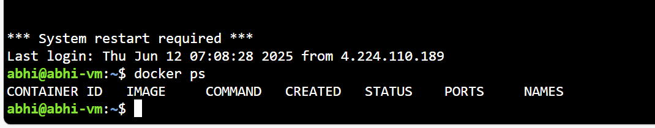

* try run the job again:

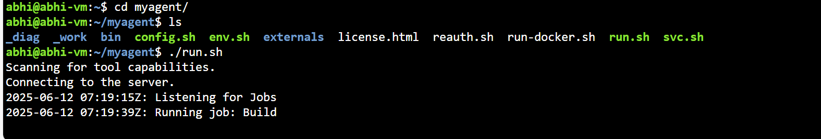

* run

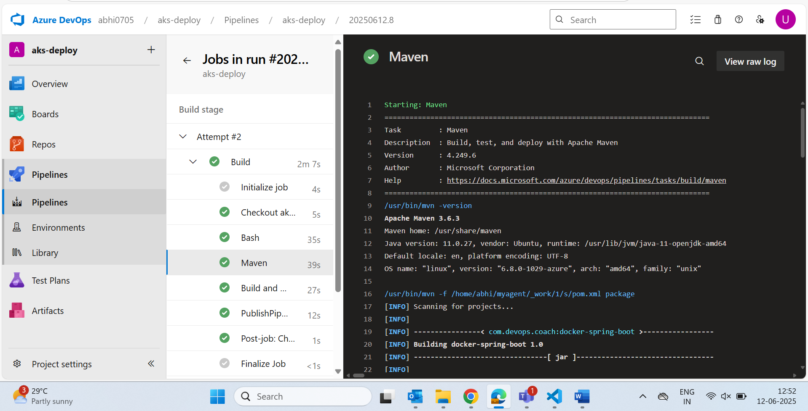

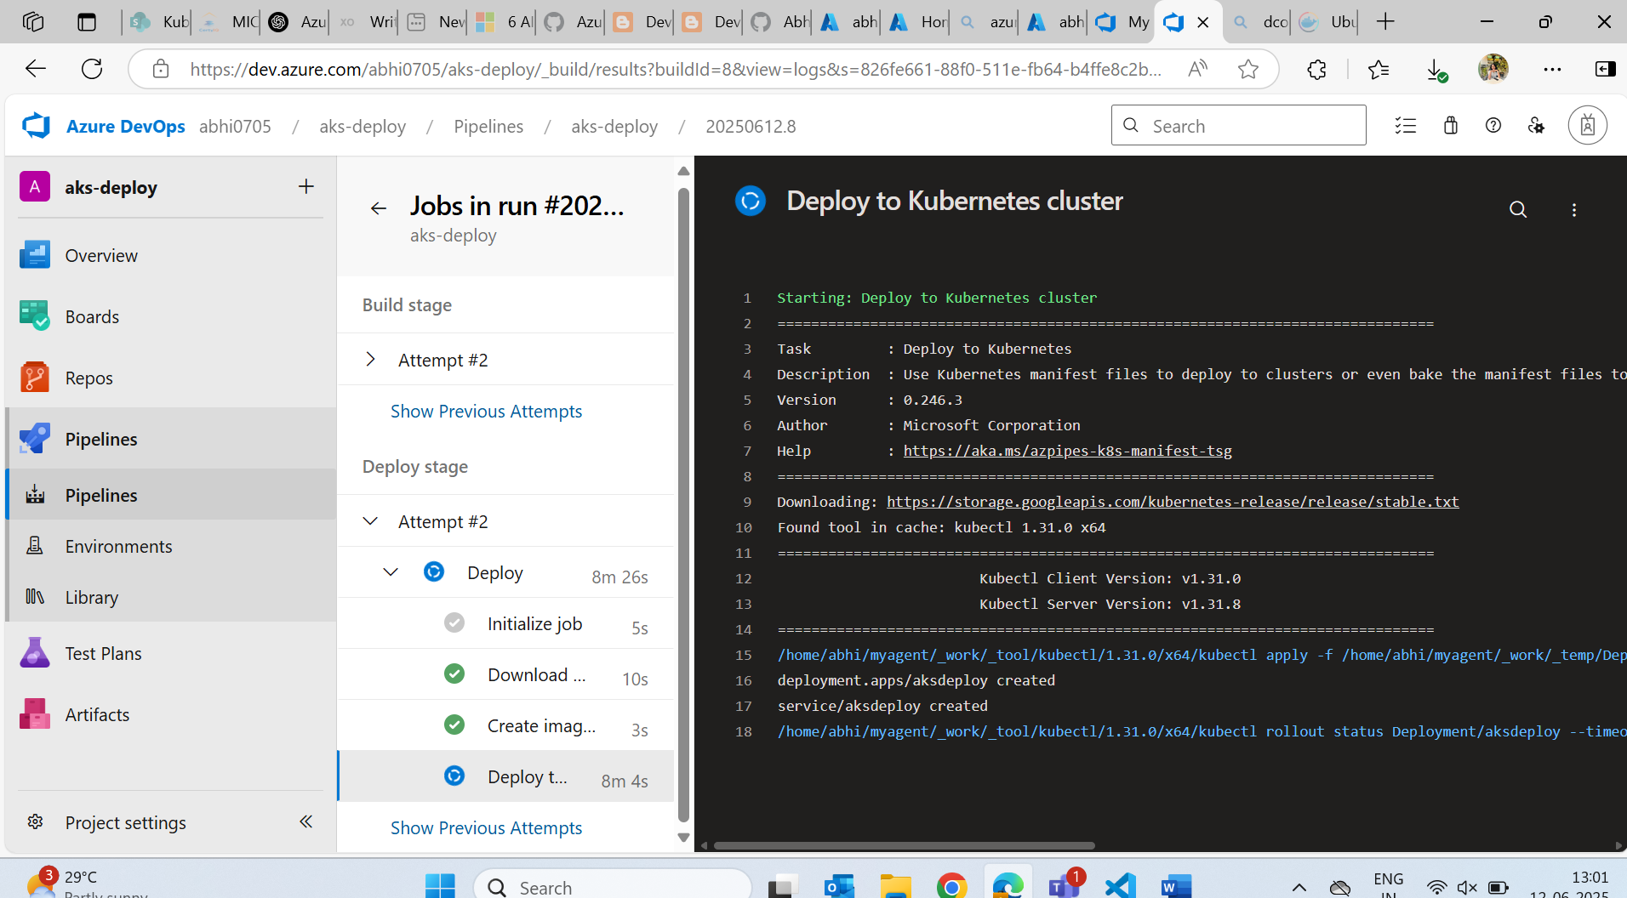

Done…